Weetabix Cake
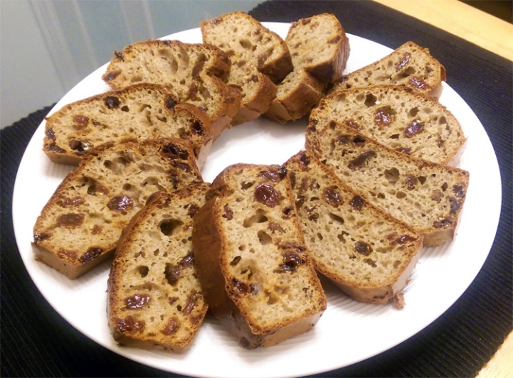
Ingredients:
- 2 Weetabix
- 200ml Milk
- 100g sultanas
- 100g self-raising flour
- 1 tsp mixed spice
- 2 Eggs beaten
Method:
- Preheat your oven to 180°C/fan 160°C/gas 4 and line a 450g loaf tin with non-stick baking paper.

- Crush the Weetabix into a large bowl and pour in the milk. Leave for 2-3 minutes then mix with a fork.

- Beat in all the remaining ingredients, spoon the mixture into the prepared loaf tin and bake for 1 hour.

- Cool the cake on a wire rack, turn out, slice and enjoy.

Tips and suggestion:
Try adding crushed bananas to your cake mix.
Instead of sultanas, you can use other dry fruits such as apricots.
No loaf tin? No worries. You can use a small cake tin or a muffin tin to make individual Weetabix cakes.

