Banana cake
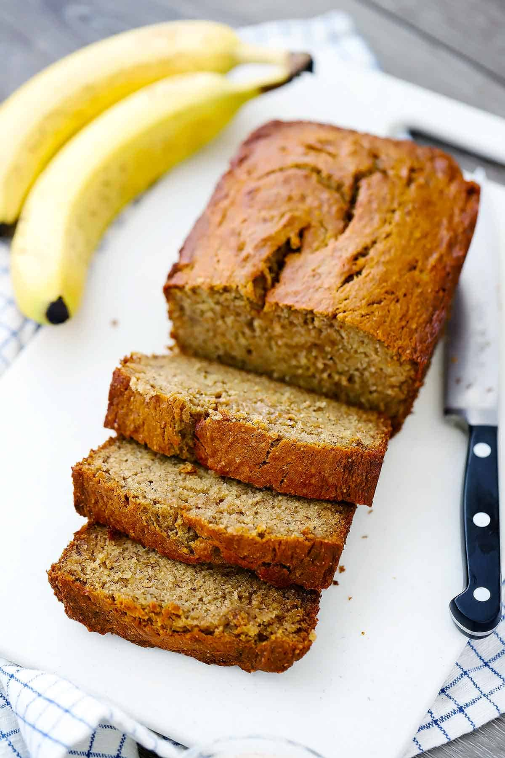
Ingredients:
- 125g self-raising flour
- 1 tsp baking powder
- 2 tsp ground cinnamon (optional)
- 75g sultana/ raisins/ dried fruit
- 50g butter, melted
- 2 tsp vanilla essence
- 1 egg
- 1 tbsp milk
- 3 ripe bananas, mashed

Instructions:
- Preheat the oven to 180C/ 160C fan/ gasmark 4.
- Grease and line a 450g loaf/1lb tin with baking parchment.
- Weigh the flour, baking powder, cinnamon and sultanas into a bowl and mix with a wooden spoon.
- Weigh the butter, vanilla essence, egg, milk and mashed bananas and put into another bowl or jug and mix with a small balloon whisk or fork.
- Pour the ‘wet’ banana mixture into the ‘dry’ flour mixture and combine thoroughly with a wooden spoon.
- Pour the cake mixture into the prepared tin and bake for 30 - 40 mins or until a skewer inserted in the middle comes out clean.
- Remove from the oven, allow to cool in the tin for 10 mins then turn out.

Enjoy!
Tips and Suggestions:

Try making individual muffins by placing the mixture into induvial muffin cases and reducing the baking time.

