Fruit Scones

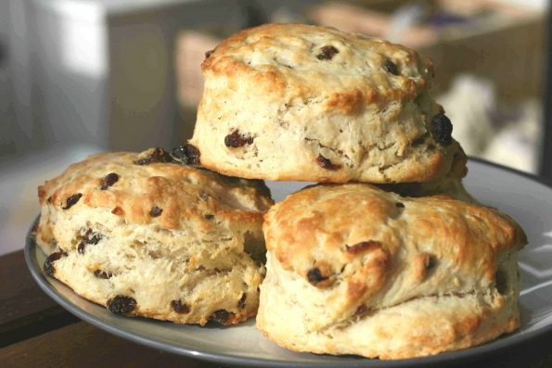
Ingredients:
- 350g self-raising flour
- ¼ tsp salt
- 1 tsp baking powder
- 85g butter, cut into cubes
- 175ml milk
- 1 tsp vanilla extract
- squeeze of lemon juice
- 100g sultanas/ raisins/ dried fruits
- beaten egg to glaze

Instructions:
- Heat oven to 220C/200C fan/gas 7.
- Tip the flour into a large bowl with the salt and baking powder, then mix. Add the butter, then rub in with your fingers until the mix looks like fine crumbs.
- Put the milk into a jug and heat in the microwave for about 30 secs until warm, but not hot. Add the vanilla and lemon juice, then set aside for a moment. Put a baking sheet in the oven.
- Make a well in the dry mix, then add the liquid and sultanas and combine it quickly with a cutlery knife – it will seem wet at first.
- Scatter some flour onto the work surface and tip the dough out. Dredge the dough and your hands with a little more flour, then fold the dough over 2-3 times until it is a little smoother.
- Rolle the dough until it’s about 4cm thick. Take a 5cm cutter (smooth-edged cutters tend to cut more cleanly, giving a better rise) Plunge into the dough, then repeat until you have used all the dough.
- Brush the tops with beaten egg, then carefully place onto the hot baking tray.
- Bake for 10 mins until risen and golden on the top.

Eat just warm or cold on the day of baking,

Tips and Suggestions

If freezing, freeze once cool. Defrost, then put in a low oven (about 160C/140C fan/gas 3) for a few mins to refresh.

No cutter? No Worries! Try using a cup/glass to cut out scone shapes or trying to cut different shapes with a knife

Make plain scones by taking out the sultana/ raisins/ dried fruit.

